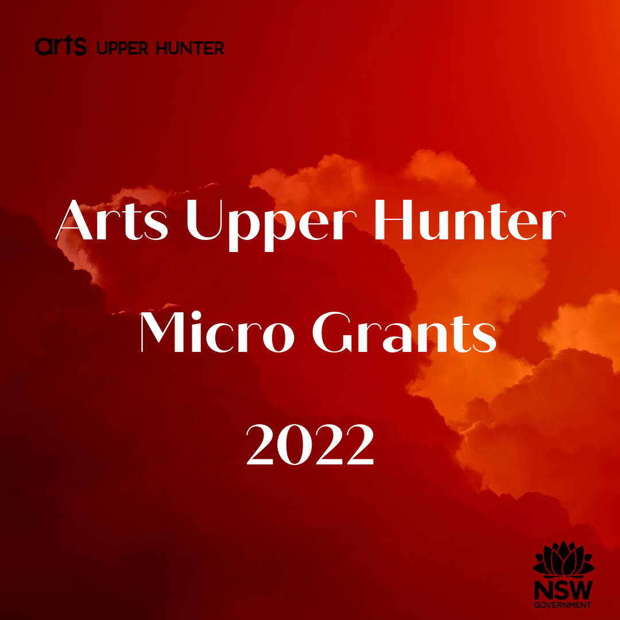

Application Form

(complete & email to rado@artsupperhunter.com.au)

Please see our guidelines click here for eligibility, conditions etc.
Applications close 5pm Monday 22 August 2022.
Enquiries please call John O’Brien on 0409 382 509

- Applicant information

Name of artist or arts organisation:
Contact person if organisation:
Email:
Phone:
Address (including postcode) of artist or arts organisation:
ABN of artist or arts organisation:
(Must be in the same name as the applicant)
Are you registered for GST? (Y/N) _____

- Biography/organisation information (up to 100 words) – A brief bio about your creative practice (including web links etc) or a brief history of your organisation.
Please expand text boxes for more space.

Answer:

- Activity Outline (up to 300 words) – Tell us about your proposed activity and how you will use the grant.
Answer:

- Benefits (up to 200 words) – What are the benefits of your proposal and to whom?
Answer:

- Supporting Material: Letters of support, links, images – please list any below and add any notes you think will help us understand them. List them here. Images and letters should be provided as an attachment.

Answer:

- Budget – Note: Income must equal expenditure
If you are registered for GST, the figures you enter should be exclusive of GST.
If you are not registered for GST, the figures should include GST
Income | $
Amount you’re asking from Arts Upper Hunter
Other income (itemise below if any)
Applicant’s own contribution if any
Total income
Expenditure (itemise below)
Total Expenditure
Add extra rows if necessary.

Declaration:
I declare that the information is accurate to the best of my knowledge.
(For arts organisations) I certify that I have the authority to complete and submit this application on behalf of the organisation.
I acknowledge that Arts Upper Hunter has the right to investigate any information provided in this application and/or to request additional information, and has the right to withdraw any offer of funding or demand the return of funds already paid if my declaration is found to be incorrect or misleading.

Name:_______________________________
Organisation (if applicable): __________________________________
Position: __________________________________
Date: ____________________

Signature: ________________________________________
(Typing your name will be taken to be as binding as a signature.)

Please email completed form and any attachments to John O’Brien at rado@artsupperhunter.com.au

