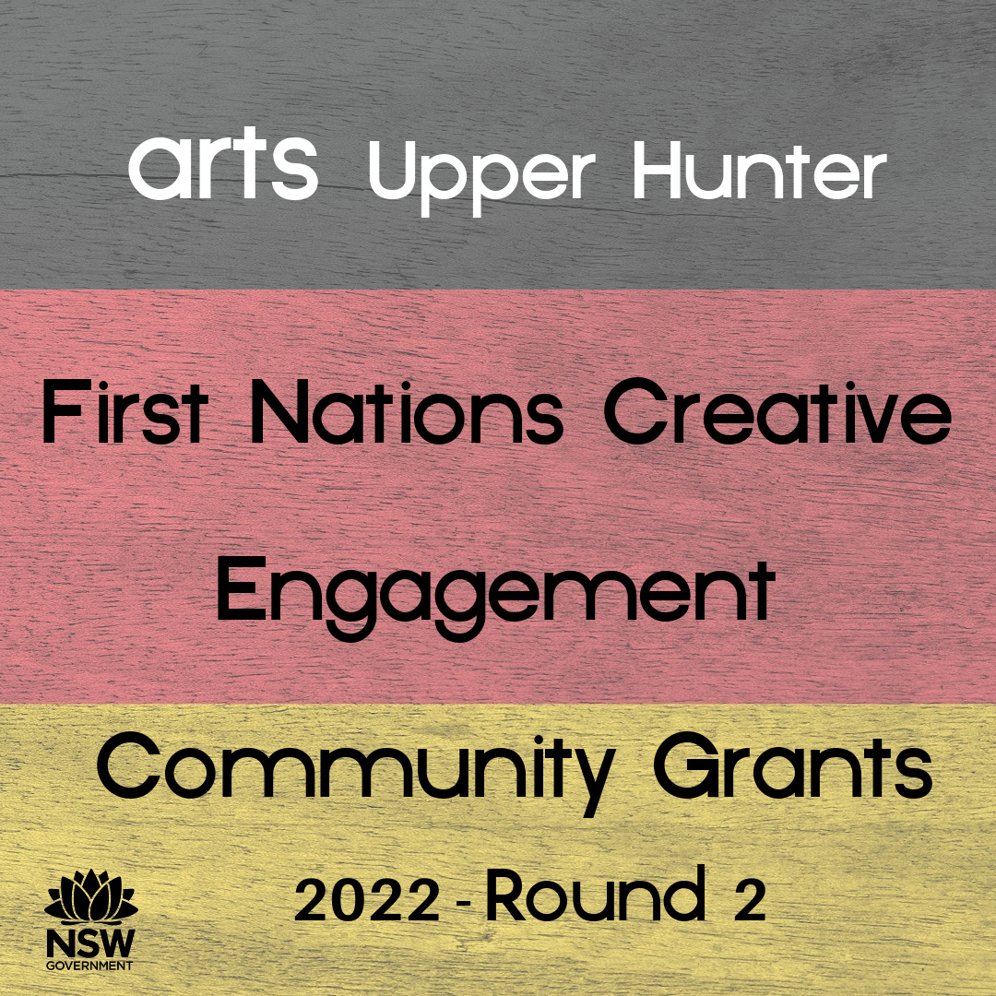

Application Form for Round 2

(complete & email to rado@artsupperhunter.com.au)

Please see our guidelines click here for eligibility, conditions etc.
Applications for round 2 close 5pm Monday 22 August 2022.
Enquiries please call John O’Brien on 0409 382 509

- Project title:

- Applicant information

Name of organisation:
Contact person:
Email:
Phone:
Address of organisation:
ABN (if a Council authority, please provide Council ABN):
(note ABN must in the name of the organisation)
Are you registered for GST? (Y/N) _____

- Organisation information (up to 125 words) – A brief history/bio of your organisation (including web links etc).
Please expand text boxes for more space.

Answer:

- Project outline (up to 300 words) – Tell us about your project and how you will use the grant.
Answer:

- Participating artists/businesses & targeted attendees (up to 125 words) - Who will be facilitating or running the project - this could be an artist, a company, an organisation. And (very important) who will be the targeted audience or attendees?

Answer:

- Benefits & outcomes (up to 200 words) – What are the benefits of your proposal and to whom? (You may include specifics such as number of workshop participants, number of artists, but also general items such as providing skills for youth, beautifying a space, promoting FN cultural practice, etc.)

Answer:

- First Nations connection (up to 200 words) – How do your organisation and this project link to the local Aboriginal community? Which groups in particular?
Answer:

- Covid impact (if any). If your organisation or program has been impacted by Covid, please provide some brief information here (up to 100 words). (A proportion of the grant funding is designated for recovery from the impact of the pandemic, though this is not essential for all successful applicants.)
Answer:

- Budget – Note: Income must equal expenditure
If you are registered for GST, the figures you enter should be exclusive of GST.
If you are not registered for GST, the figures should include GST
Income | $
Amount you’re asking from Arts Upper Hunter
Other income (itemise below if any)
Applicant’s own contribution if any
Total income
Expenditure (itemise below)
Total Expenditure
Add extra rows if necessary.

- In-kind support. Please list any in-kind support, such as number of volunteers, free or discount venue hire, gifted materials, cultural advice, etc. You may estimate a dollar figure for these if you wish.
Answer:

- Working With Children Check (if relevant). Please list the names of any adults who will be working with under 18s and provide their WWCC numbers.
Answer:
- Other evidence. Please tell us anything else you think is important for us to consider in assessing your application. This might include Letters of Support, statistics, images or videos, and links to artists and their work. Please attach Letters of Support and images to the email with your application.
Answer:

Declaration:
I certify that I have the authority to complete and submit this application on the group’s behalf.
I declare that the information in this form is accurate to the best of my knowledge.
I acknowledge that Arts Upper Hunter has the right to investigate any information provided in this application and/or to request additional information, and has the right to withdraw any offer of funding or demand the return of funds already paid if my declaration is found to be incorrect or misleading.

Name:_______________________________

Position: __________________________________

Date: ____________________

Signature: ________________________________________
(Typing your name will be taken to be as binding as a signature.)

Please email completed form and any attachments to John O’Brien at rado@artsupperhunter.com.au

